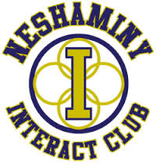
The Neshaminy Interact Club will host a ColorFest on Saturday, April 18th from 11:30 – 3:30 to benefit the Glut1DS Foundation. Gracie, a second grader at Herbert Hoover Elementary School, was the 86th person in the world diagnosed with this disorder when she was two; currently, there are only 500 known cases worldwide.
Glucose Transporter Type 1 Deficiency Syndrome is a rare genetic disorder that impairs brain metabolism, but what does that really mean? Most of us have Glut1 (a protein) in our bodies to help transport glucose (a sugar) to our brains. Individuals with Glut1DS have a damaged gene and their bodies don’t make the protein, sugar doesn’t get carried to the brain and the brain is starved of energy. Most people with Glut1DS have seizures which many control with medication and/or the Ketogenic diet and developmental delays.
The Interact Club would like to celebrate the spirit of the families impacted by the disorder by raising awareness in a fantastically fun way – a ColorFest! What is a ColorFest exactly? Throughout India, the arrival of spring is celebrated through Holi. Markets are filled with colored powders in anticipation of the festival and entire communities pause for the festivities which include music, dancing and lots and lots of color.
We would love you to join us as we bring this energy to Neshaminy High School. All registrants ($15 by April 10, $20 thereafter) will receive:
- Official ColorFest t-shirt
- One packet of color
- I “I love someone with Glut1DS” bracelet
- Entrance into the “ColorZone”
Family and friends are welcome to join in the festive atmosphere provided by our DJ, the Neshaminy High School Yoga Club and Dance Team along with a variety of vendors.
Any questions regarding this event can be directed to Suzi Drake, Interact Club Advisor, via email sdrake@neshaminy.k12.pa.us , phone 215-809-6100 or through the Neshaminy Interact Club Facebook page.

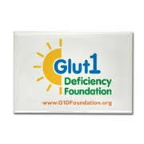
ColorFest Registration Form
Event Details
Date: April 18, 2015
Location: Neshaminy High School
2001 Old Lincoln Highway
Langhorne, PA 19047
Time: 11:30 – 3:30
Packet Pick-up: 2:30 – 5:00 Friday, April 17th
Registration opens at 10:30 on April 18th
Weather: This is a rain or shine event.
Questions? Suzi Drake at sdrake@neshaminy.k12.pa.us or 215-809-6100
Name:
Address:
Phone Number:
Email:
Shirt Size (Please circle)
YM YL AS AM AL AXL AXXL

Some additional information:

http://www.g1dfoundation.org/wp-content/uploads/2012/01/G1D-brochure-v2.pdf
https://www.youtube.com/watch?v=BdbzSTsUVQ8

